**8093 UAT TEST**

**APEX TEST SCREENSHOTS & ERROR MESSAGES**

1. **VanInvoice Interface to Omega.**

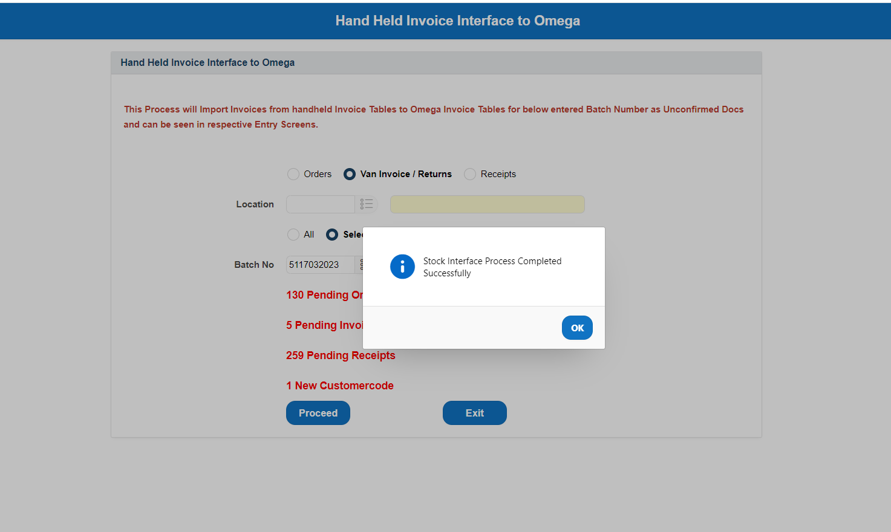

Pushed successfully to omega.

**2. Van Invoice HH Confirmation**

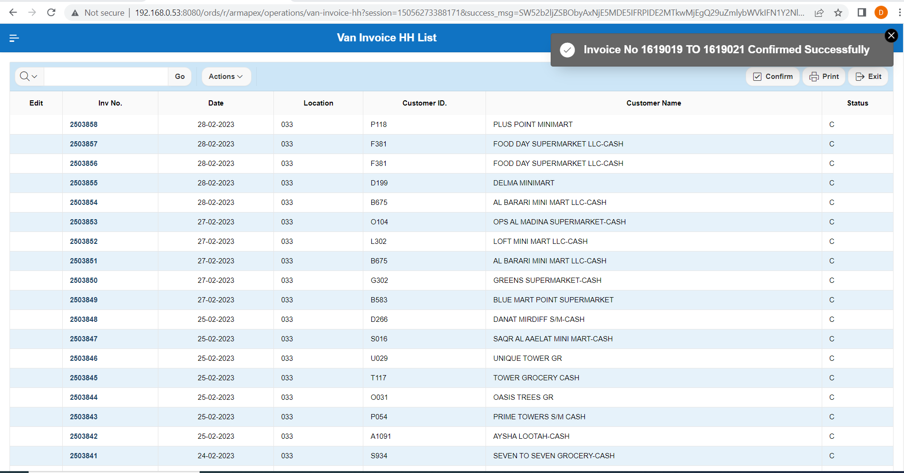

Still showing for confirmation in selection List.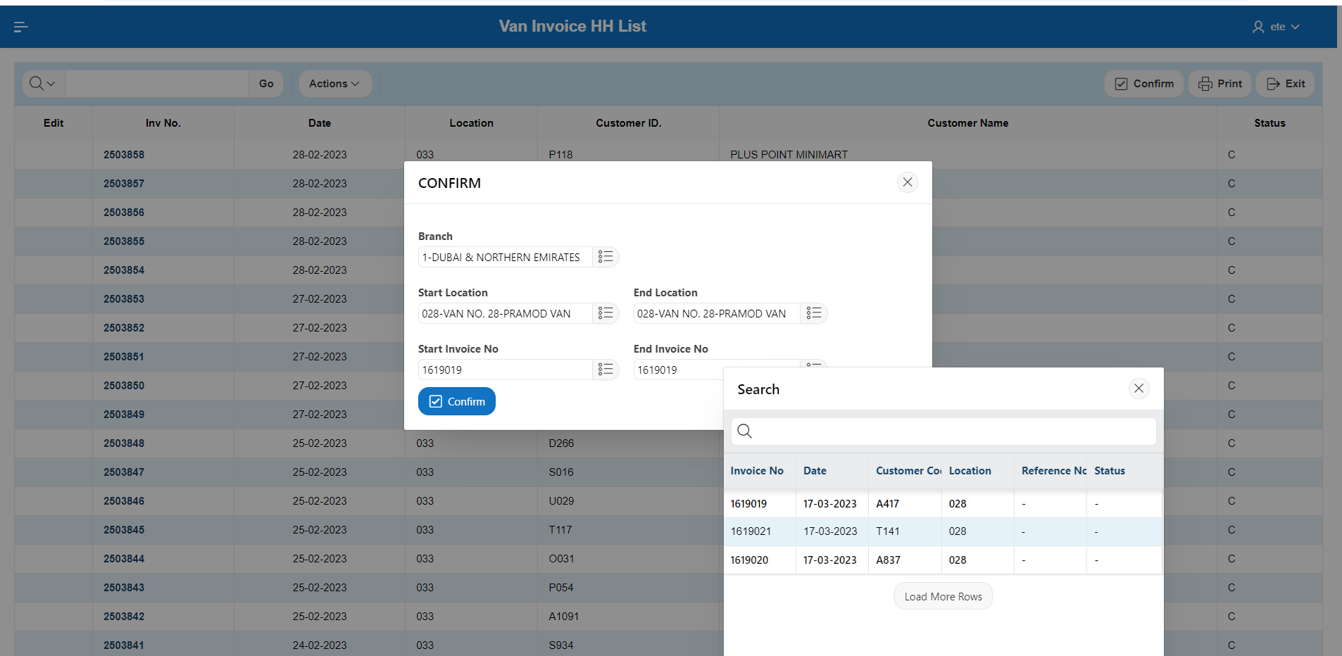

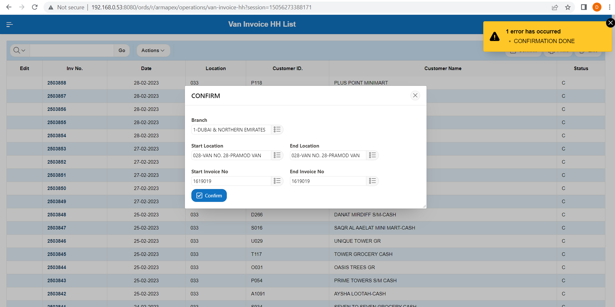

Cannot find in Van Invoice HH List for the confirmed invoice.

**3. Van Presales order**

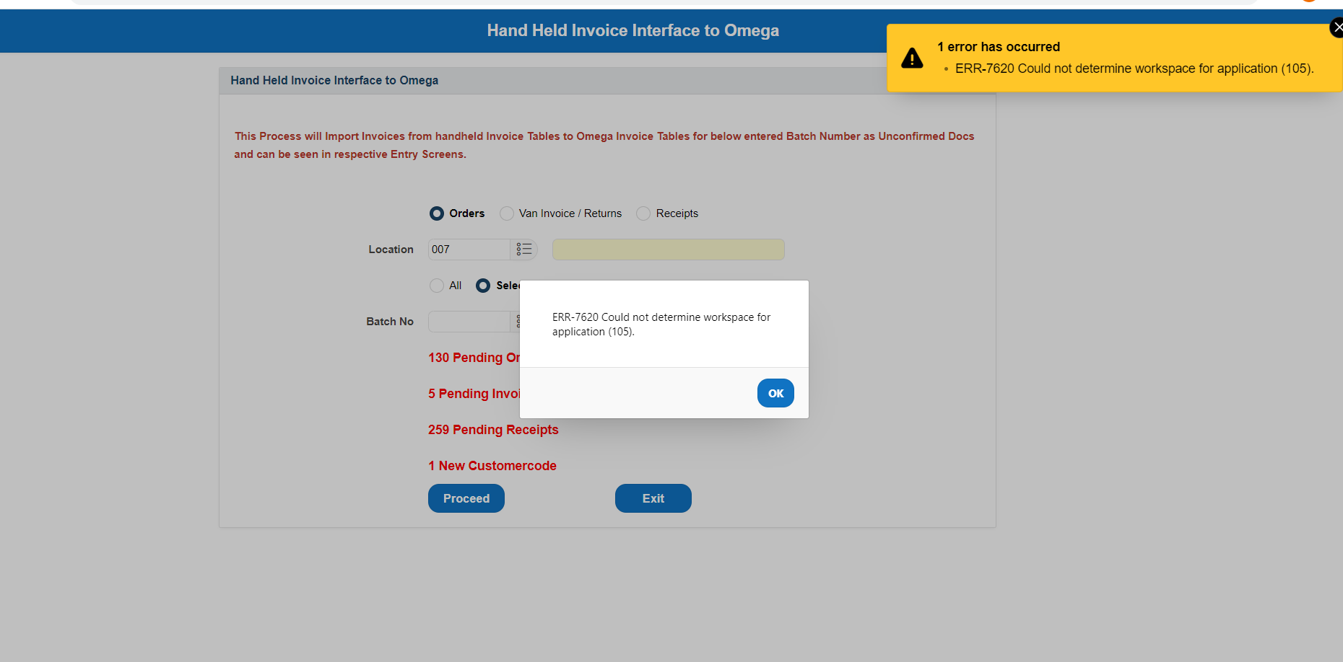

Getting Error When trying to select batch number from the list.

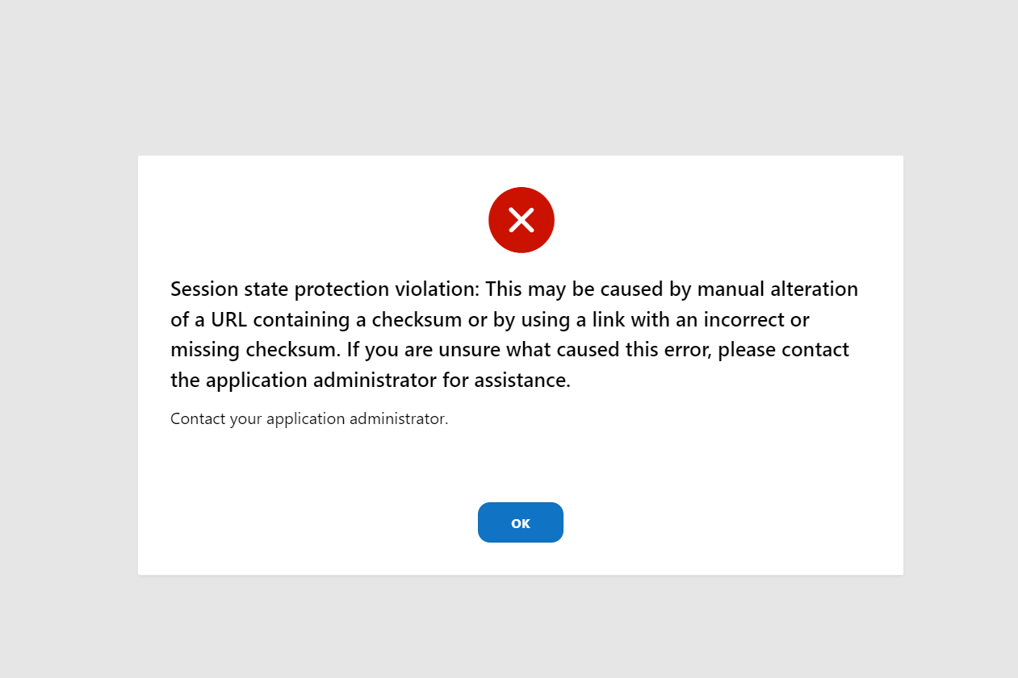

Getting Error when clicking Exit Button.

**4. VTN (Van transfer Note) Push in interface.**

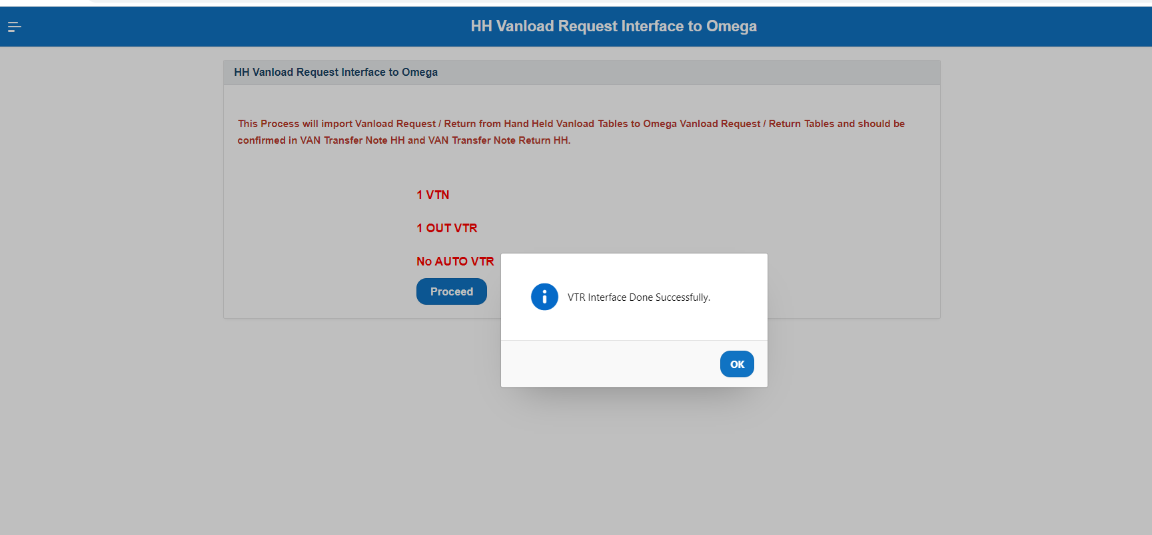

Pushed to omega.

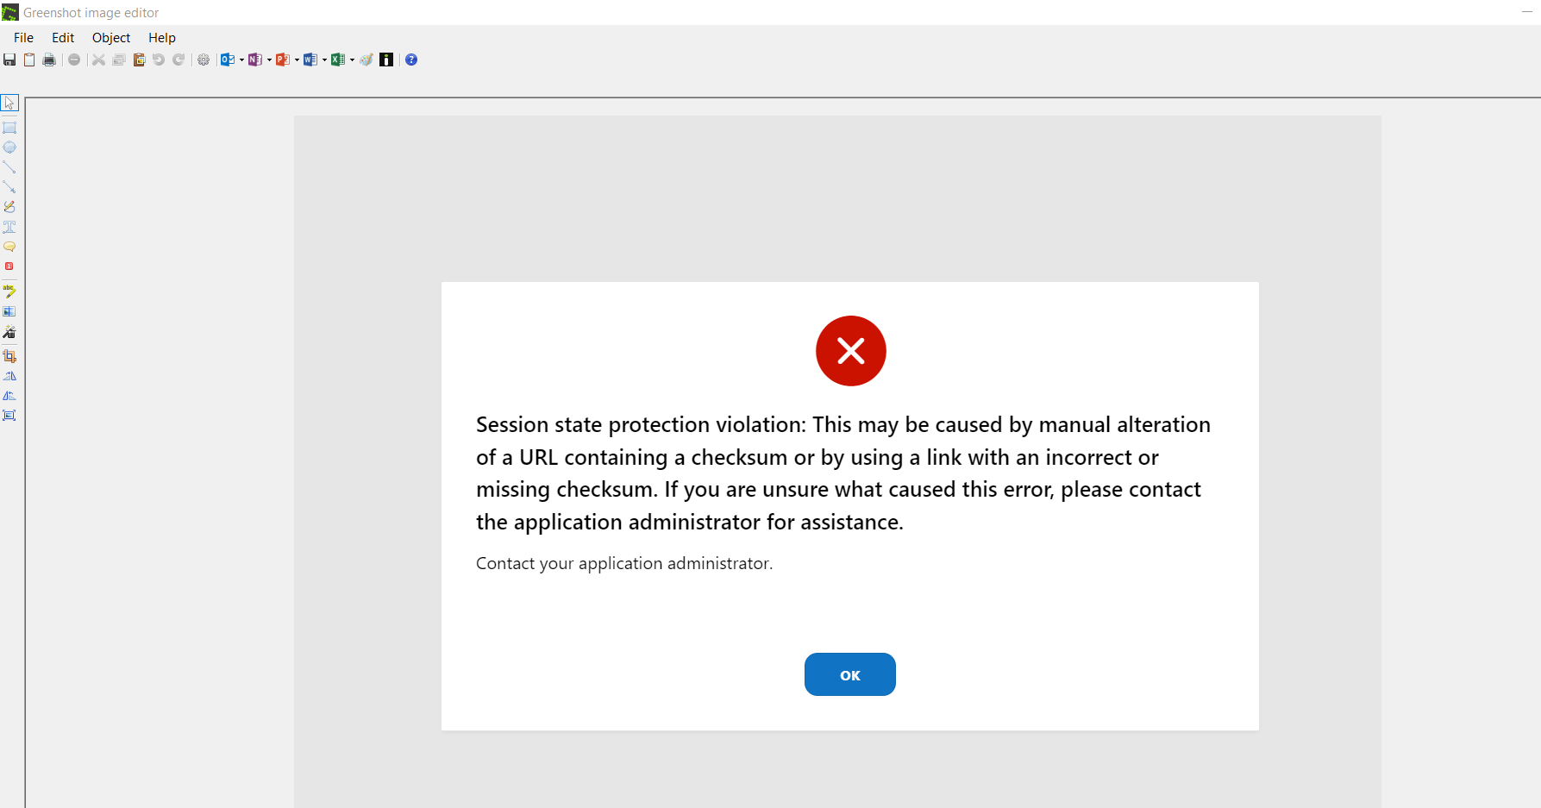

Error when clicking Exit HH Vanload Request interface to omega.

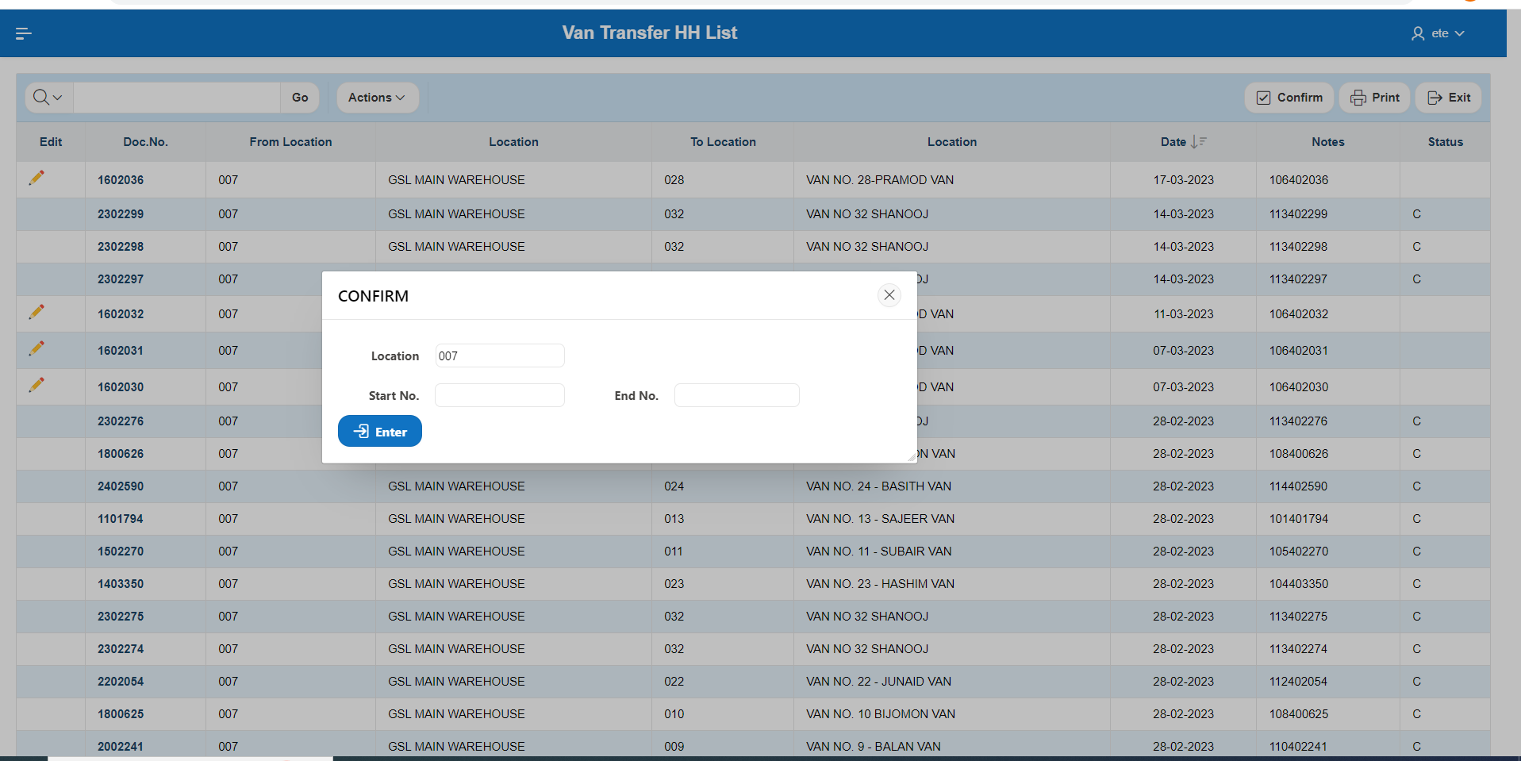

1. Unable to find VTN document for confirmation.
2. Selection list is not showing.

**5. VTNR – Van transfer Note return Push in interface.**

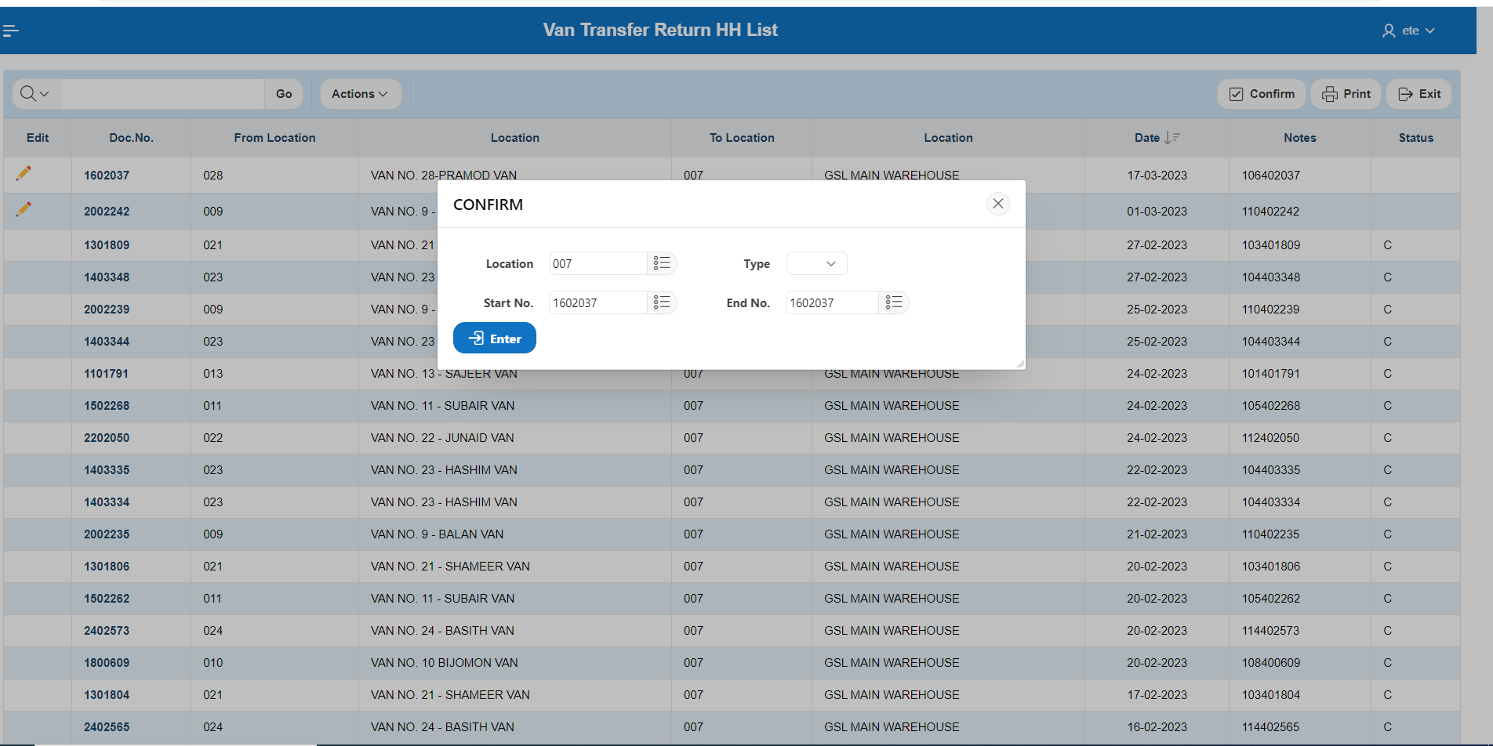

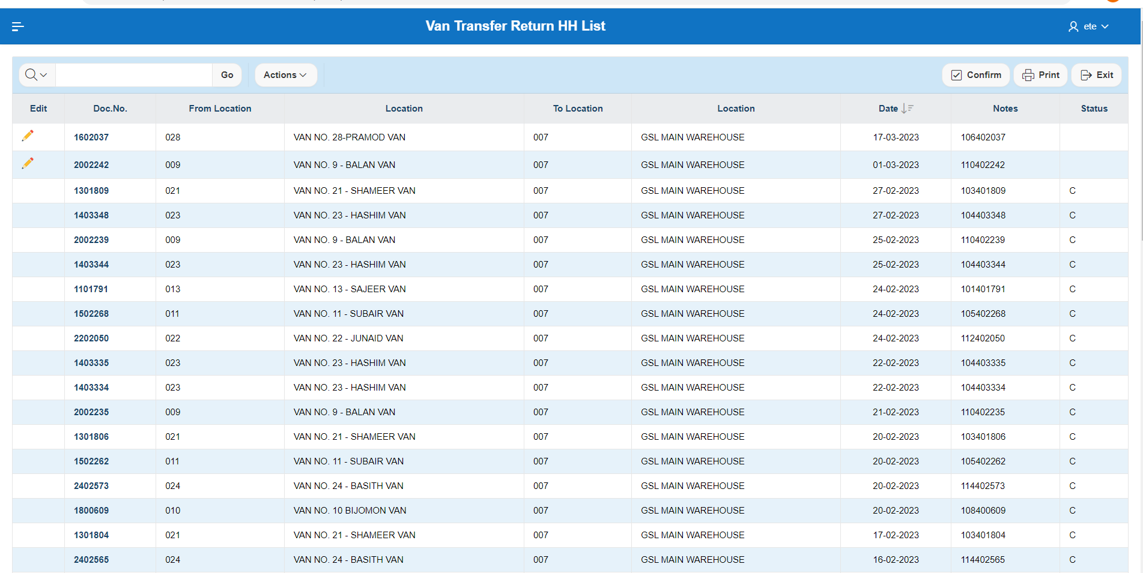

Unable to Confirm.